* Verificación del puerto actual:

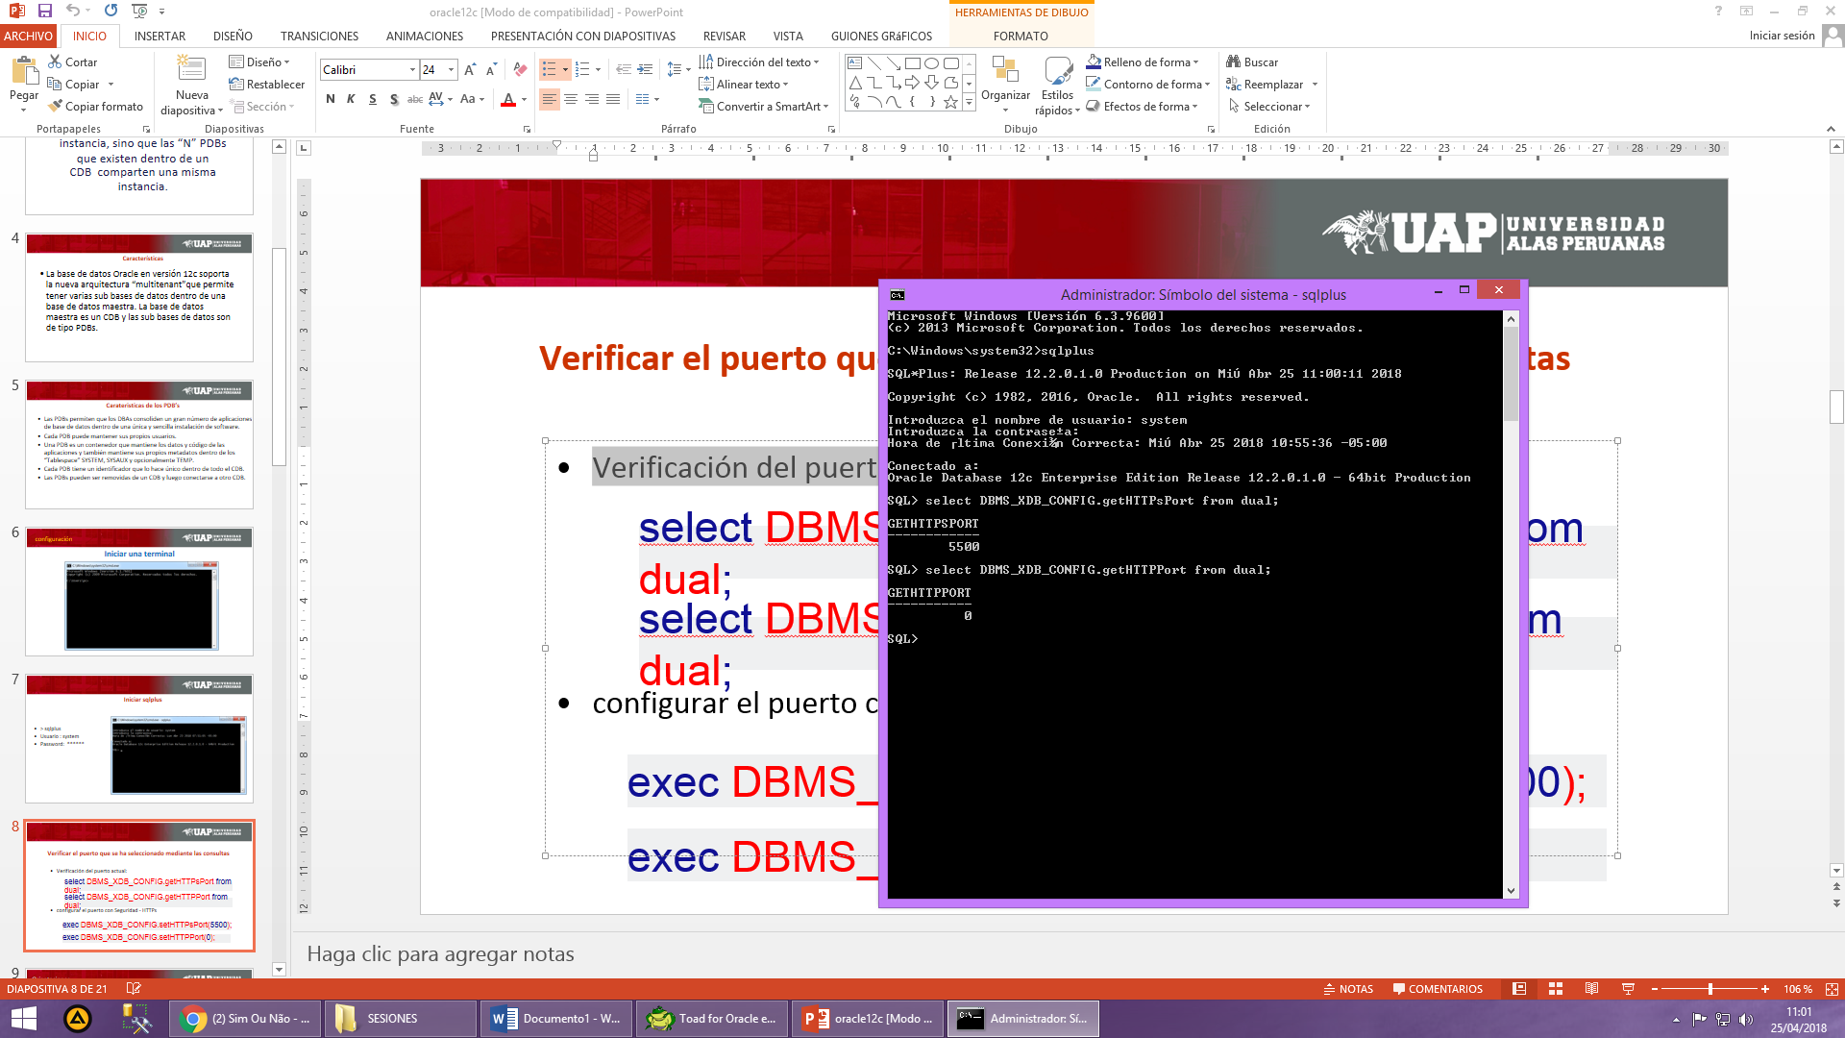

* configurar el puerto con Seguridad – HTTPs

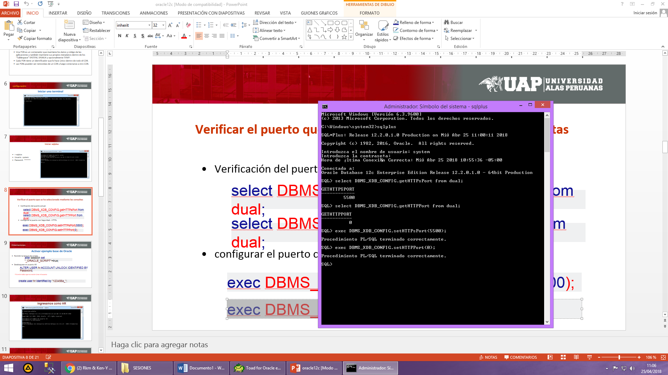

* Permitir la lectura de scripts.

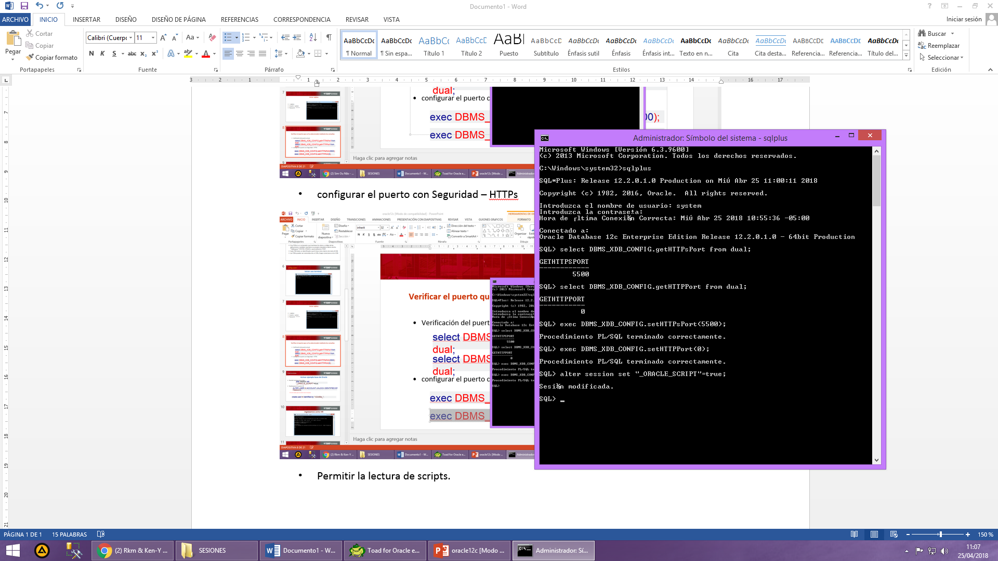

* Desbloquear el usuario HR

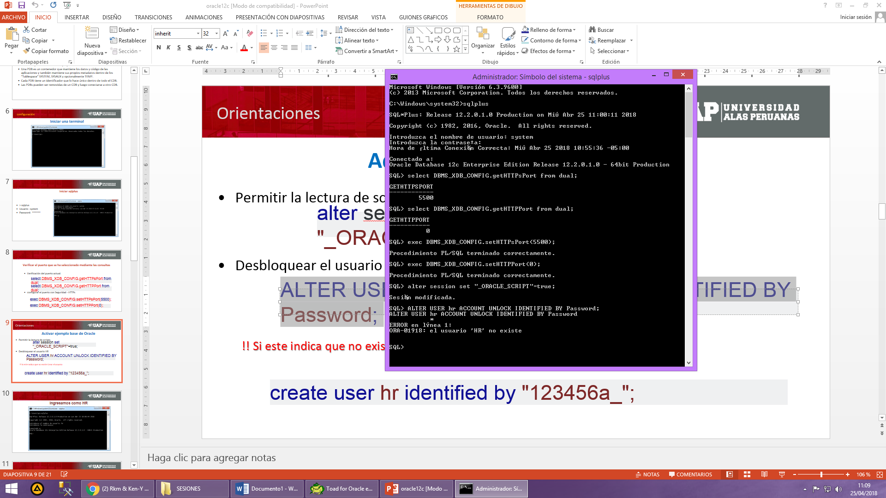

!! Si este indica que no existe Crear el usuario

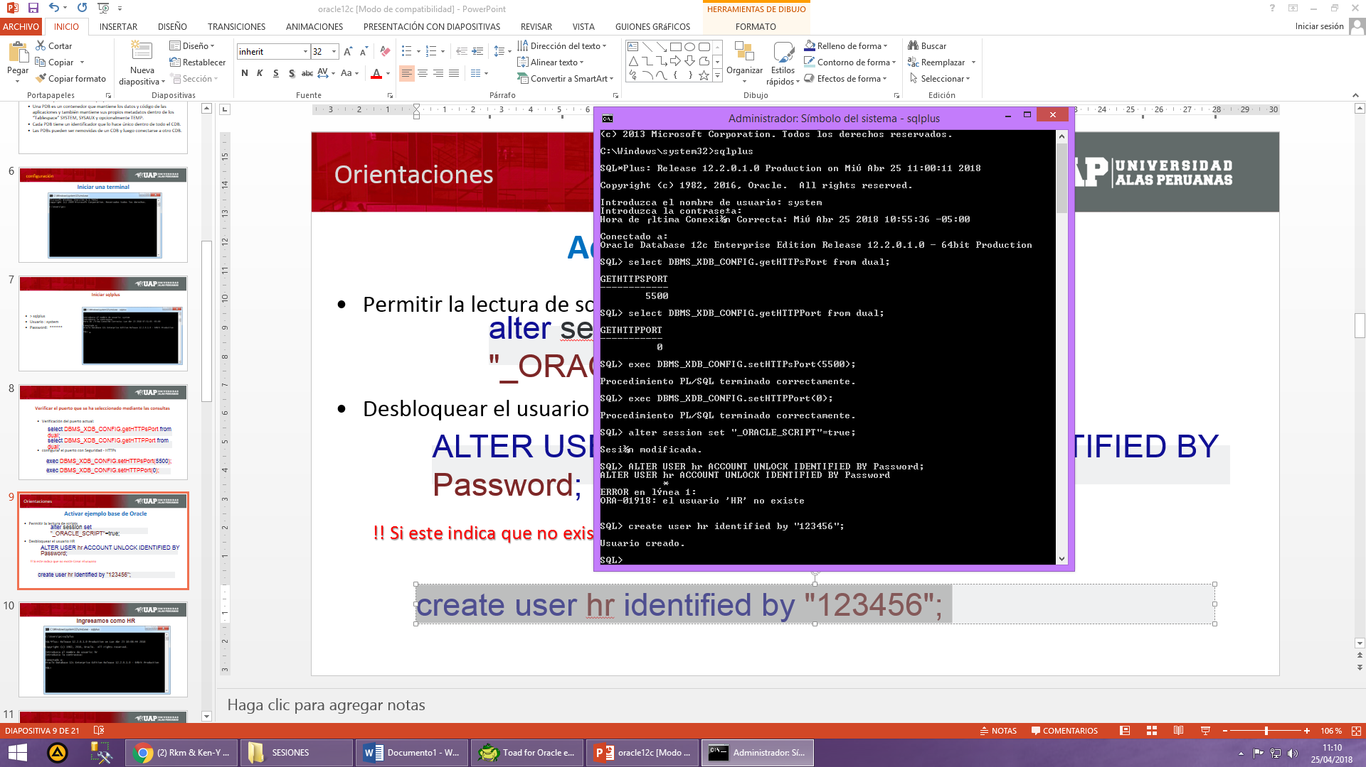

* **Ingresamos como HR**

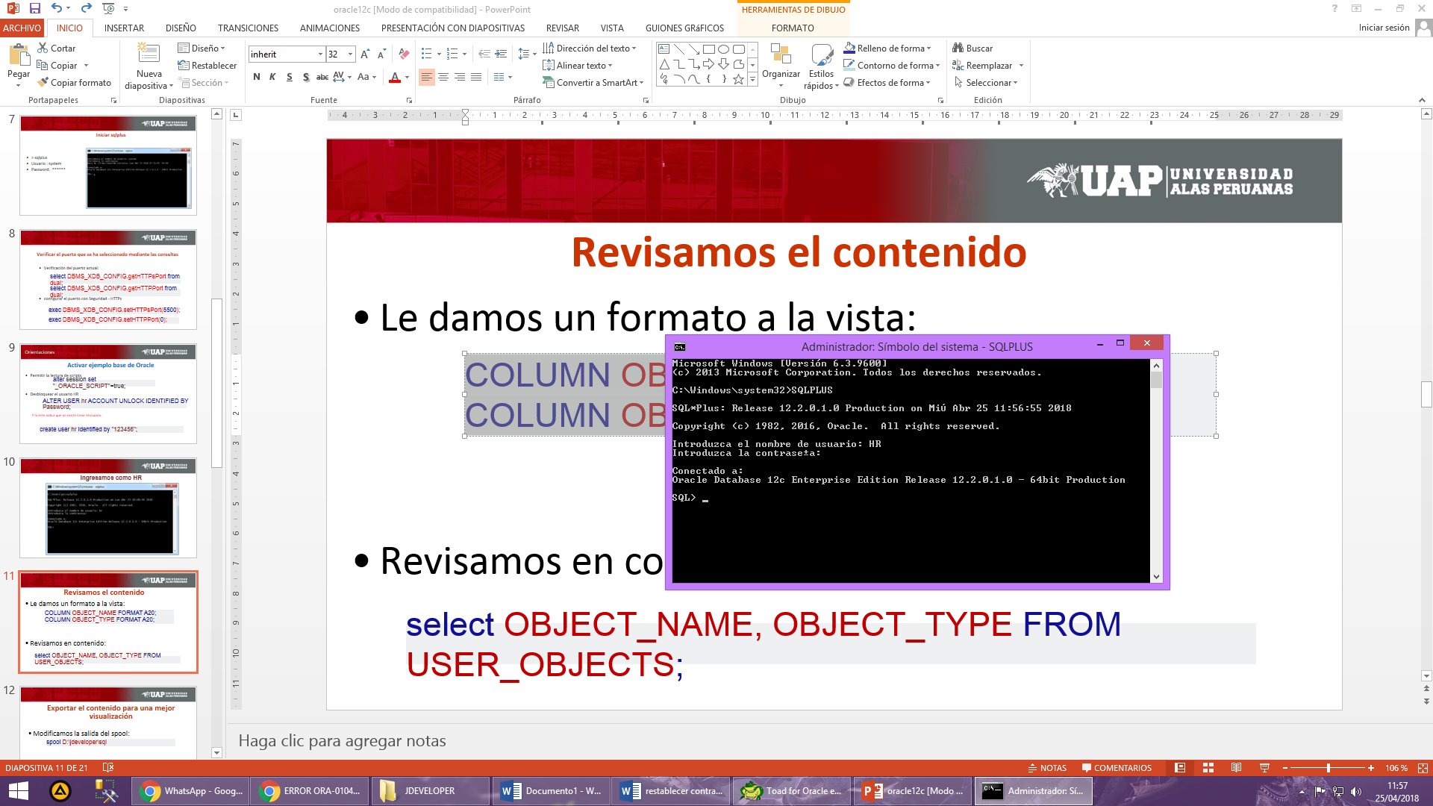

* Le damos un formato a la vista:
* Revisamos en contenido:

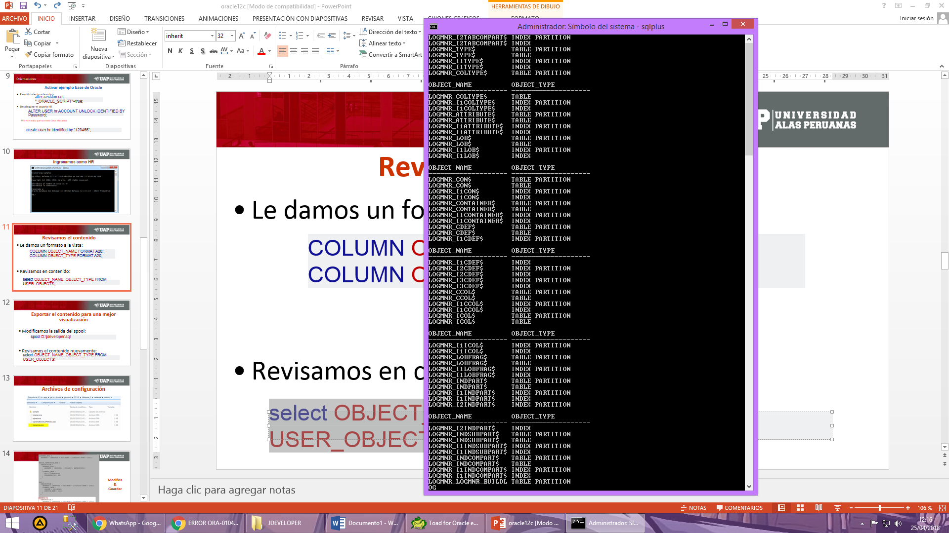

**Exportar el contenido para una mejor visualización**

* Modificamos la salida del spool:

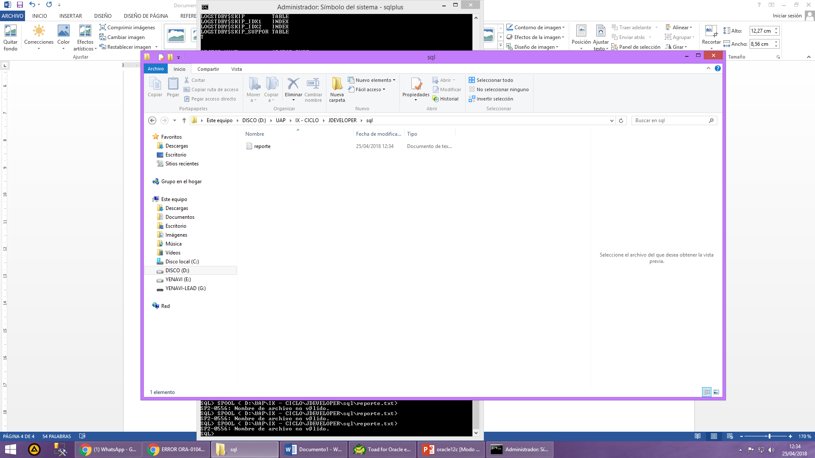

**REPORTE DE TABLAS – 7 TABLAS**

1. **JOB_HISTORY – CON 10 REGISTROS**

|  |  |  |  |  |
| --- | --- | --- | --- | --- |
|  | CLAVE | TIPO DATO | INDEX POS | NULL |
| EMPLOYEE_ID | PK | NUMBER (6) | 1, 1 | NO |
| START_DATE | FK | DATE | 2 | NO |
| END_DATE |  | DATE |  | NO |
| JOB_ID |  | VARCHAR2 (10 Byte) | 1 | NO |
| DEPARTMENT_ID |  | NUMBER (4) | 1 | YES |

1. **EMPLOYEES – CON 107 REGISTROS**

|  |  |  |  |  |
| --- | --- | --- | --- | --- |
|  | CLAVE | TIPO DATO | INDEX POS | NULL |
| EMPLOYEE_ID | PK | NUMBER (6) | 1 | NO |
| FIRST_NAME |  | VARCHAR2 (20 Byte) | 2 | YES |
| LAST_NAME |  | VARCHAR2 (25 Byte) | 1 | NO |
| EMAIL |  | VARCHAR2 (25 Byte) | 1 | NO |
| PHONE_NUMBER |  | VARCHAR2 (20 Byte) |  | YES |
| HIRE_DATE |  | DATE |  | NO |
| JOB_ID |  | VARCHAR2 (10 Byte) | 1 | NO |
| SALARY |  | NUMBER (8,2) |  | YES |
| COMMISSION_PCT |  | NUMBER (2,2) |  | YES |
| MANAGER_ID |  | NUMBER (6) | 1 | YES |
| DEPARTMENT_ID |  | NUMBER (4) | 1 | YES |

1. **JOBS: CON 19 REGISTROS**

|  |  |  |  |  |
| --- | --- | --- | --- | --- |
|  | CLAVE | TIPO DATO | INDEX POS | NULL |
| JOB_ID | PK | VARCHAR2 (10 Byte) | 1 | NO |
| JOB_TITLE |  | VARCHAR2 (35 Byte) |  | NO |
| MIN_SALARY |  | NUMBER (6) |  | YES |
| MAX_SALARY |  | NUMBER (6) |  | YES |

1. **DEPARTMENTS - CON 27 REGISTROS**

|  |  |  |  |  |
| --- | --- | --- | --- | --- |
|  | CLAVE | TIPO DATO | INDEX POS | NULL |
| DEPARTMENT_ID | PK | NUMBER (4) | 1 | NO |
| DEPARTMENT_NAME |  | VARCHAR2 (30 Byte) |  | NO |
| MANAGER_ID |  | NUMBER (6) |  | YES |
| LOCATION_ID |  | NUMBER (4) | 1 | YES |

1. **LOCATIONS – CON 23 REGISTROS**

|  |  |  |  |  |
| --- | --- | --- | --- | --- |
|  | CLAVE | TIPO DATO | INDEX POS | NULL |
| LOCATION_ID | PK | NUMBER (4) | 1 | NO |
| STREET_ADDRESS |  | VARCHAR2 (40 Byte) |  | YES |
| POSTAL_CODE |  | VARCHAR2 (12 Byte) |  | YES |
| CITY |  | VARCHAR2 (30 Byte) | 1 | NO |
| STATE_PROVINCE |  | VARCHAR2 (25 Byte) | 1 | YES |
| COUNTRY_ID |  | CHAR (2 Byte) | 1 | YES |

1. **COUNTRIES – CON 25 REGISTROS**

|  |  |  |  |  |
| --- | --- | --- | --- | --- |
|  | CLAVE | TIPO DATO | INDEX POS | NULL |
| COUNTRY_ID | PK | CHAR (2 Byte) | 1 | NO |
| COUNTRY_NAME |  | VARCHAR2 (40 Byte) |  | YES |
| REGION_ID |  | NUMBER |  | YES |

1. **REGIONS - 4 REGISTROS**

|  |  |  |  |  |
| --- | --- | --- | --- | --- |
|  | CLAVE | TIPO DATO | INDEX POS | NULL |
| REGION_ID | PK | NUMBER | 1 | NO |
| REGION_NAME |  | VARCHAR2 (25 Byte) |  | YES |